ENV260

Dr. Chaudhary

Winter 2018

Twyla Neely-Streit

Lab 3

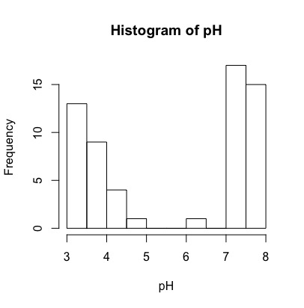1.

2. The data could be described as bi-modal or double-peaked, however the highest frequency is found at 7 pH. Both low pH and high pH seem to lead to higher frequency. There is low to no frequency in the 5-6 range.

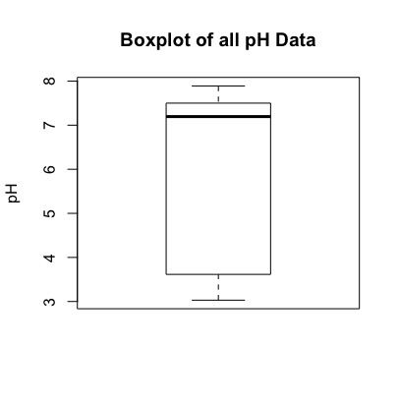

3.

4. The boxplot.stats(pH) function displays a set of five numbers: 3.030 3.615 7.195 7.500 7.890. These numbers represent the low point of the “lower whisker”, “lower hinge”, the median of the data, the “upper hinge” and the high point of the “upper whisker”.

5. Both graphs show that the data is fairly stratified, therefore a mean which shows a point somewhere in the middle of the pH scale would be meaningless.

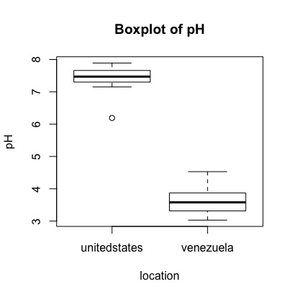6.

7. Yes- The boxes do not touch. The outlier of the US data is not even close to touching the upper confidence interval of Venezuela, which shows confidence that there is a significant difference in soil pH between the two country sites.

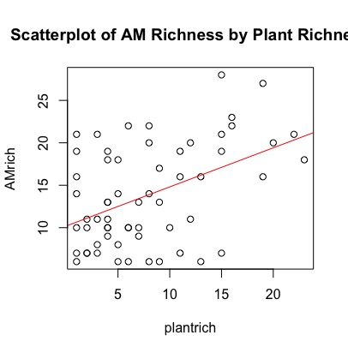8.

10. y=0.4606x+10.2012

y=Amrich x=Plantrich

positive relationship, more AM means more plant richness.